AFFIDAVIT OF SERVICE

FEDERAL COURT OF CANADA

BETWEEN:

Radu Hociung
Plaintiff, Appellant

and

Minister of Public Safety and Emergency Preparedness
Defendent, Respondent

AFFIDAVIT OF SERVICE

I, Radu Hociung, of the Solidaridad in the Quintana Roo state of Mexico, SWEAR THAT:

- I served the Minister Minister of Public Safety and Emergency Preparedness with Reply to his Additional Written Submissions by sending a copy by email on December 5, 2019 to Eric Peterson, solicitor for the Respondent at Eric.Peterson@justice.gc.ca, which he acknowledged and accepted.

_____________________________
Radu Hociung

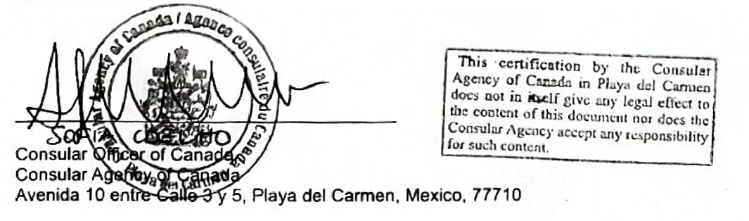
Sworn before me at the city of Playa del Carmen, in the Quintana Roo state of Mexico on December 9, 2019.

